**Ain Shams University**  
**Faculty of Computer & Information Sciences**

**Computer Science Department**

**Careium**

**(AI Food Tracker)**

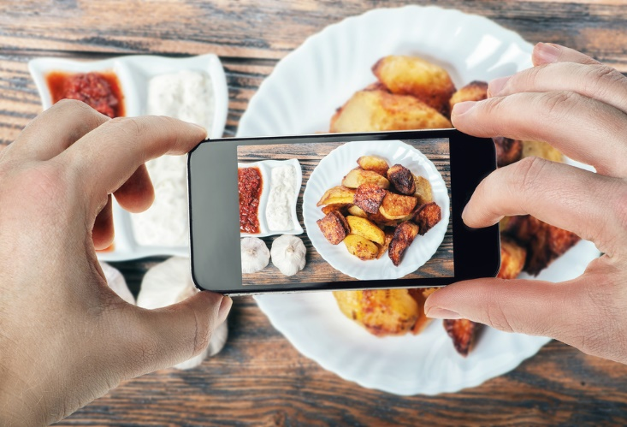

**July 2020**

**Ain Shams University**  
**Faculty of Computer & Information Sciences**

**Computer Science Department**

**Careium**

**(AI Food Tracker)**

**By:**

|  |  |
| --- | --- |
| Kareem Sherif Fathy | [Computer Science] |
| Kareem Saeed Ragab | [Computer Science] |
| Abanoub Asaad Azab | [Computer Science] |
| Nada El Sayed Anies | [Computer Science] |
| Nada Mohamed Abd Elhamed | [Computer Science] |

**Under Supervision of:**

Dr. Sally Saad

Computer Science Department,

Faculty of Computer and Information Sciences,

Ain Shams University.

TA. Mohamed Essam

Bioinformatics Department,

Faculty of Computer and Information Sciences,

Ain Shams University.

# Acknowledgment

First of all, the first few words must be our sincere thanks and appreciation that goes to every single person who guided us during the long journey and the work period. Special thanks to **Dr. Sally Saad** for being a supportive person before being the compass that guided us during the whole year. Also, we could not forget to credit our **TA. Mohamed Essam** for his support and his continuous advice to complete and reach the end of our targets.

Many thanks to the team members that revealed new skills in each other and responsibilities to take new risks. Finally, we thank our families for being supportive of us in any step that we sought and we still seek to it. So we are sincerely thankful to them but mostly to Allah.

# Abstract

At this extreme moment, we began working from home, away from campus, and keeping social distance from as many people as possible. As we stay home and stick with the foods that have been in our fridge, we are temporarily living a sedentary lifestyle with increased odds of physical inactivity, excessive eating and sitting, stress, anxiety, and depression. Many of us will gain some weight during the pandemic and may keep the extra weight permanently, which may carry considerable health risks for type 2 diabetes, hypertension, heart attack, stroke, and other health problems. This is where the importance of **Careium Artificial Intelligence (AI) Food Tracker** comes in.

Accordingly, the **Careium AI Food Tracker** (Android) application helps diabetes, liver patients, and those who want to track their health throughout the day through daily meals by calculating the calories and minerals per each meal by taking a picture of the meal, and the application detects the food type and analyzes its calories and minerals. Also, the application follows up gaining or losing weight, or even avoiding some food due to allergies. That is achieved using Deep Learning and Image Processing.

**Careium AI Food Tracker** shows astonishing results compared to what was expected for a simple use case example. Capturing the food plate, long dish, deep dish or even scattered amount of food, Careium can still segment the food region, process it and predicts the main five **nutrition components** *(Calories, Mass, Fat, Carbs, Proteins)*. Calories are measured in cal, all others are measured in grams. It can be used in **classifying** a mixed dish of food into multiple food categories, generating food eaten **reports** periodically, **recommending** a proper meal from a set of different available meals in a given dataset and giving **alarms** for each mealtime.

**Table of Contents**

**Chapter Page**

1. **Introduction 1**

**\_\_\_\_\_\_\_\_\_\_\_\_\_\_\_\_\_\_\_\_\_\_\_\_\_\_\_\_\_\_\_\_\_\_\_\_\_\_\_\_\_\_\_\_\_\_\_\_\_\_\_\_\_\_\_\_\_\_\_\_\_\_\_\_\_\_\_\_\_\_\_\_\_\_\_\_\_**

1.1 Motivation…………………………………………………………………. 2

1.2 Problem Definition…………………………………………..…………….. 3

* 1. Objective……………………………………………………..…………….. 4

1.4 Time Plan …………………………………………………..……………… 5

1.5 Document Organization……………………………………………………. 6

1. **Background 7**

**\_\_\_\_\_\_\_\_\_\_\_\_\_\_\_\_\_\_\_\_\_\_\_\_\_\_\_\_\_\_\_\_\_\_\_\_\_\_\_\_\_\_\_\_\_\_\_\_\_\_\_\_\_\_\_\_\_\_\_\_\_\_\_\_\_\_\_\_\_\_\_\_\_\_\_\_\_**

2.1 Description of the Project………………………………………………….... 8

2.2 Scientific Background Related to the Project……………………………….. 9

2.3 Survey of the Work………………………………………....……………….. 12

2.4 Description of Existing Similar Systems…………………………………….. 13

2.5 Description of Used Technologies…………………………………………… 14

1. **Analysis and Design 15**

**\_\_\_\_\_\_\_\_\_\_\_\_\_\_\_\_\_\_\_\_\_\_\_\_\_\_\_\_\_\_\_\_\_\_\_\_\_\_\_\_\_\_\_\_\_\_\_\_\_\_\_\_\_\_\_\_\_\_\_\_\_\_\_\_\_\_\_\_\_\_\_\_\_\_\_\_\_**

**3.1** **System Overview** **16**

3.1.1 System Architecture……………………………………………………. 16

3.1.2 System Users…………………………………………...………………. 19

**3.2** **System Analysis and Design 20**

3.2.1 Use Case Diagram…………………………….…………………….…. 20

3.2.2 Class Diagram……………………………..….………………………... 21

3.2.3 Sequence Diagram………………………........………………………… 22

3.2.4 Database Diagram…………………………….………………………... 26

1. **Implementation and Testing 27**

**\_\_\_\_\_\_\_\_\_\_\_\_\_\_\_\_\_\_\_\_\_\_\_\_\_\_\_\_\_\_\_\_\_\_\_\_\_\_\_\_\_\_\_\_\_\_\_\_\_\_\_\_\_\_\_\_\_\_\_\_\_\_\_\_\_\_\_\_\_\_\_\_\_\_\_\_\_**

1. **User Manual 33**

**\_\_\_\_\_\_\_\_\_\_\_\_\_\_\_\_\_\_\_\_\_\_\_\_\_\_\_\_\_\_\_\_\_\_\_\_\_\_\_\_\_\_\_\_\_\_\_\_\_\_\_\_\_\_\_\_\_\_\_\_\_\_\_\_\_\_\_\_\_\_\_\_\_\_\_\_\_**

1. **Conclusion and Future Work 37**

6.1 Conclusion……………………………………………..………………. 38

6.2 Future Work……………………………………………..………………. 39

1. **References 40**

# List of Figures

**Figure Figure Caption Page**

* Figure 2.2.1 *1st paper* *CNN Accuracy*  9
* Figure 2.2.2 *2nd paper* *Food Recognition Result* 10
* Figure 2.2.3 *3rd paper Food Volume Equations* 11
* Figure 2.3 *Survey Form of the Work* 12
* Figure 2.4 *Existing Systems Comparison* 13
* Figure 3.1.1 *Careium System Architecture* 16
* Figure 3.2.1 *Use Case Diagram* 20
* Figure 3.2.2 *Class Diagram* 21
* Figure 3.2.3 *Login* *Sequence* *Diagram* 22
* Figure 3.2.3 *Meal Alarm* *Sequence* *Diagram* 23
* Figure 3.2.3 Food Tracker *Sequence* *Diagram* 24
* Figure 3.2.3 Recommendation *Sequence* *Diagram* 25
* Figure 3.2.4 *Database* *Diagram* 26
* Figure 5.2.1 *Getting Started (Home)* 34
* Figure 5.2.2 *Getting Started (Login)* 34
* Figure 5.2.3 *Getting Started (Register F1)* 35
* Figure 5.2.4 *Getting Started (Register F2)* 35
* Figure 5.2.5 *Getting Started (Register F3)* 35
* Figure 5.2.6 *Getting Started (Tracker)* 36

# List of Abbreviations

* **AI:** Artificial Intelligence
* **APK:** Android Application Package
* **CNN:** Convolutional Neural Network
* **DL:** Deep Learning
* **Faster R CNN:** Faster Region-based Convolutional Neural Networks
* **IP:** Image Processing
* **ML:** Machine Learning
* **UI:** User Interface
* **UML:** Unified Modeling Language

\_\_\_\_\_\_\_\_\_\_\_\_\_\_\_\_\_\_\_\_\_\_\_\_\_\_\_\_\_\_\_\_\_\_\_\_\_\_\_\_

*Chapter 1*

*Introduction*

\_\_\_\_\_\_\_\_\_\_\_\_\_\_\_\_\_\_\_\_\_\_\_\_\_\_\_\_\_\_\_\_\_\_\_\_\_\_\_\_

## **Motivation**

Estimating the main components in pictures of food is a demanding task, and it helps individuals achieve optimal, balanced dietary intakes. Yet this task turns out to be difficult for both experts and non-experts. We are using this study as an opportunity to enhance our understanding of whether and how calorie estimation works in real-world scenarios. There are many applications of this understanding, ranging from improving the methodological rigor and reducing the associated burden of dietary assessment, a pervasive and unanswered question in nutrition science, as well as influencing the design of interventions focused on dietary behavior change.

Since individuals can’t estimate food components well, it has motivated the design of software applications to help individuals better estimate different aspects of dietary intake (e.g., calories, sugars, proteins, nutrient density) using deep learning (DL). Apps in this area remain quite difficult to use, requiring burdensome manual logging of what one eats, or, when DL is used to classify pictures of foods, explicit weight values to be entered manually. To a large extent, the identification of components content from images of food, either through crowdsourcing or deep learning, remains an open research question. This work is a necessary step towards the automated identification of components content from images of food.

## **Problem Definition**

Nowadays almost 20% [**[1]**](#References_1) of deaths worldwide are attributable to an unhealthy diet. 39% of adults aged 18 years and over were overweight, and 13% were obese.​ Most of the world’s population lives in countries where overweight and obesity kill more people than underweight.

The problem here is not about having enough food, it is about people who don’t know how to track their day from waking up to sleeping. So **Careium** will be a helpful friend to any user that wants to track his or her daily healthcare activities.

Some Problems Careium-AI is going to solve:

* + Whether the meal fully healthy for the body?
  + Whether the body get enough quantity of minerals?
  + Whether the daily progress consistent?

## **1.3 Objective**

The main goal is to make body health better, and this is going to be achieved by some features like:

* Detecting food type and ingredients using Deep Learning (**DL)** and Convolution Neural Network (**CNN)**.
* Estimating food’s main components i.e. (calories, sugars, proteins, etc...).
* Reminding of each mealtime.
* Recommending food that suits the desired target using **CNN**.
* Generating daily reports of the consumed food components per meal.
* Making warnings if the current meal is not suitable for reaching the target.
* Managing time between meals.
* Setting a special program to keep following up on the current status and how close reaching the target.

## **1.4 Time Plan**

|  |  |
| --- | --- |
| **2021** | **2022** |

|  |  |  |  |  |  |  |  |  |  |  |
| --- | --- | --- | --- | --- | --- | --- | --- | --- | --- | --- |
| PHASE | OCT | NOV | DEC | JAN | FEB | MAR | APR | MAY | JUN | JUL |
| **Project Preparation**  - Reading related papers  - Gathering sample datasets. |  |  |  |  |  |  |  |  |  |  |
| **System Design** |  |  |  |  |  |  |  |  |  |  |
| **Project Implementation**  - ML Model  - Front-end  - Back-end |  |  |  |  |  |  |  |  |  |  |
| **Project Integration**  **+ Testing**  - Core and models testing |  |  |  |  |  |  |  |  |  |  |
| **Project Deployment** |  |  |  |  |  |  |  | C:\Users\Eng_Kareem\AppData\Local\Microsoft\Windows\INetCache\Content.Word\Done2.png |  |  |

## **1.5 Document Organization**

Chapter 2:

Includes:

* A detailed description of the project field and all scientific background related to the project.
* A survey of the work done in the field.
* Description of existing system’s functionalities and different from the project being developed.

Chapter 3:

Includes:

* Functional requirements.
* Nonfunctional requirements.
* System architecture.
* Users of the system.
* Unified Modeling Language (UML) diagrams.

Chapter 4:

Includes:

* A detailed description of all the functions in the system.
* A detailed description of all the techniques and algorithms implemented.
* User Interface (UI) Design.
* Testing procedures and levels used.

Chapter 5:

Includes:

* Screenshots of the system to show how it operates.

Chapter 6:

Includes:

* Conclusion of the whole project with the results obtained.
* Future work to improve the performance of the project.

\_\_\_\_\_\_\_\_\_\_\_\_\_\_\_\_\_\_\_\_\_\_\_\_\_\_\_\_\_\_\_\_\_\_\_\_\_\_\_\_

*Chapter 2*

*Background*

\_\_\_\_\_\_\_\_\_\_\_\_\_\_\_\_\_\_\_\_\_\_\_\_\_\_\_\_\_\_\_\_\_\_\_\_\_\_\_\_

* + 1. **Description of the Project**

Careium is an Android Mobile application that helps to maintain a healthy life. The user provides his related data i.e. (weight, height, age, whether he abstains from certain food, etc…). Careium manages the human body health plan by Managing and Reminding the user of each mealtime and Making warnings if the current meal is not suitable for reaching the target.

Careium has the advantage of estimating food ingredients, by getting food images using the mobile camera or uploading a pre-captured image to the application, resulting in related info of it such as Food’s Nutrition Components.

Careium recommends food based on the user’s info (Content-based recommendation) and his last activities (Experimental recommendation). Careium also generates periodically reports (daily/monthly: based on the user choice) of the consumed food components per meal according to the user activities.

* + 1. **Scientific Background Related to the Project**
* **Food Detection and Recognition Using Convolutional Neural Network paper** [**[2]**](#References_2)**:**

The researchers praised the effectiveness of CNNs for food image recognition and detection. They found out that CNN performed much better than traditional methods using handcrafted features. Through observation of trained convolution kernels, they confirmed that color features are essential to food image recognition. The researchers applied CNN to food detection, finding that CNN significantly outperformed a baseline method.

Figure 2.2.1: 1st paper CNN Accuracy

* **Food recognition: a new dataset, experiments and results paper** [**[3]**](#References_3)**:**

In the paper, researchers designed a suitable automatic tray analysis pipeline that takes a tray image as input, finds the regions of interest and predicts for each region the corresponding food class. The researchers evaluated three different classification strategies using several visual descriptors. The best performance has been obtained by using Convolutional-Neural-Networks-based features.

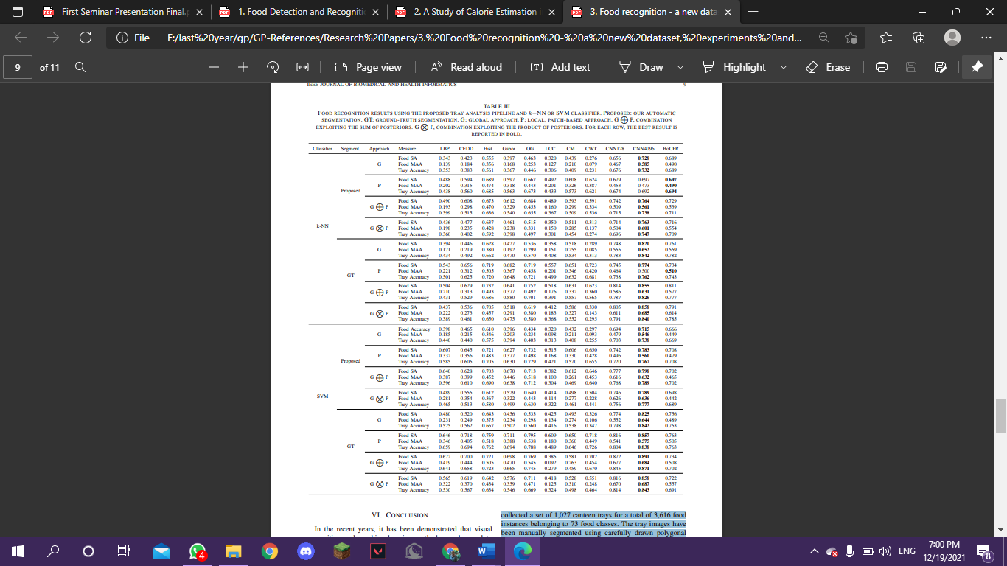

Figure 2.2.2: 2nd paper Food Recognition Result

* **Deep Learning-Based Food Calorie Estimation Method in Dietary Assessment** [**[4]**](#References_4)**:**

Their method includes 5 steps: image acquisition, object detection, image segmentation volume estimation, and calorie estimation. To estimate calories, it requires the user to take a top view and a side view of the food before eating with a smartphone. Each image used to estimate must include a calibration object; in their experiments. The researchers use the One Yuan coin as a reference. To get better results, they choose to use Faster Region-based Convolutional Neural Networks (Faster R-CNN) to detect objects and GrabCut as segmentation algorithms. To estimate the volume of each food they used the next equations.

(2.50cm) is the coin’s real diameter

Figure 2.2.3: 3rd paper Food Volume Equations

* + 1. **Survey of the Work**

We posted an online Google Form Survey on different social media apps to provide us with important statistical analysis and most importantly, how the idea we are on motivated the common people.

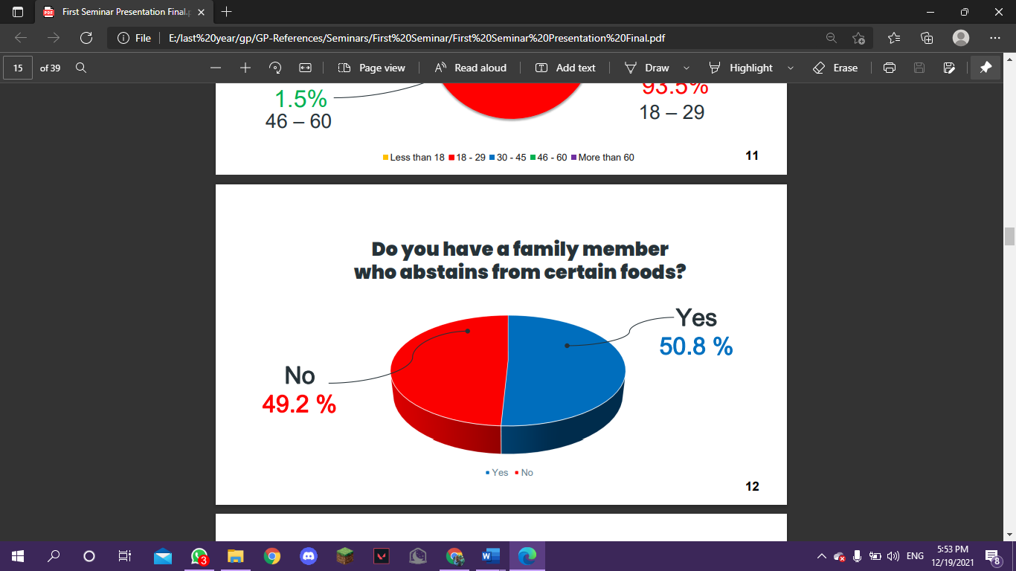

Figure 2.3 Survey Form of the Work

* + 1. **Description of Existing Similar Systems**
* HealthifyMe [**[5]**](#References_5):

A mobile application that provides smart meal plans, Customized workout plans with certified fitness coaches, and Tracks daily calorie intake, weight goals, and workouts. Sleep monitoring, meal journal & step counter. Health advice recipes, and a daily dose of motivation for fitness goals through fresh content on the app's feed.

* MyFitnessPal [**[6]**](#References_6)**:**

A mobile application that gives accurate nutrition facts for over 14 million foods. Easily log everything eaten to the food diary. Engaged online community of 200 million members. 250+ healthy recipes. 150+ workouts keep routines fresh and fun. Logging Food by scanning a barcode.

**\*\*Careium Comparison with the Existing applications\*\***

Figure 2.4 Existing Systems Comparison

* + 1. **Description of Used Technologies**
* CNN

In deep learning, a convolutional neural network (CNN) is a class of artificial neural networks, most applied to analyze visual imagery. Most convolutional neural networks are only equivariant, as opposed to invariant, to translation. They have applications in image and video recognition, recommender systems, image classification, image segmentation, medical image analysis, natural language processing, brain-computer interfaces, and financial time series.

* Image processing

Digital image processing is the use of a digital computer to process digital images through an algorithm. As a subcategory or field of digital signal processing, digital image processing has many advantages over analogue image processing. It allows a much wider range of algorithms to be applied to the input data and can avoid problems such as the build-up of noise and distortion during processing. Since images are defined over two dimensions (perhaps more) digital image processing may be modelled in the form of multidimensional systems.

\_\_\_\_\_\_\_\_\_\_\_\_\_\_\_\_\_\_\_\_\_\_\_\_\_\_\_\_\_\_\_\_\_\_\_\_\_\_\_\_

*Chapter 3*

*Analysis and Design*

\_\_\_\_\_\_\_\_\_\_\_\_\_\_\_\_\_\_\_\_\_\_\_\_\_\_\_\_\_\_\_\_\_\_\_\_\_\_\_\_

## **3.1 System Overview**

### **3.1.1 System Architecture**

Figure 3.1.1 Careium System Architecture

* **Food Detection Model** takes an image as an input and by using CNN, the Image Label results whether the image contains food or not.
* **Food Recognition Model** takes food labels as an input, and extracts food components using CNN.
* **Food Recommendation Model** is decomposed into Content-based recommendation which is related to the user's personal info and Experimental recommendation which is the recommendations according to the previous user activities.
* **Report Generation Module** generates reports according to the statistics based on user activities.

### **3.1.2 Functional Requirements**

* User Authentication when they sign into the application.
* Logging the data of users when they sign up for the application.
* Users can sign in to the application by syncing with Facebook or Gmail accounts.
* Users shall specify their goal ex: build muscles, lose weight, gain weight or stay away from a specific ingredient.
* Receiving the uploaded or taken image of the meal from the user.
* Logging the uploaded or taken image of the meal.
* Tracking the components of the meal.
* Alert the user if one of the components is not suitable for the specified goal.
* Setting times for meals and waiting for the user to send the meal on time.
* Alert the user if the meal is not sent on time.
* Suggesting meals for the user based on the ingredients of the meals previously stored.
* Make periodic reports based on the user's activity during the previous period.
* Users can make notes on specific days or specific meals.

### **3.1.3 Non-Functional Requirements**

* Performance: Action Processes and Predictions’ responses should be   
  within 5 seconds.
* Performance: The Server Cloud should load in 3 seconds when the number of simultaneous users are > 10,000.
* Performance: The application models should correctly extract the components of the meal at an accuracy of 80%.
* Reliability: The application should save/cash the information of the users.
* Usability: The application should have simple UI to be easily used and easily accessible (A simple use of light-colored theme).
* Availability: Neither the application nor the server should fall out in any time.
* Localization: The Application should be localized to the Arabian regions.

### **3.1.4 System Users**

***Intended Users:***

In general, anyone can use the application, but it is intended for these people:

* **Dieter:**

They provide a picture of the dish to the application that calculates the calories, the amount of fat per meal and if it is suitable for his diet.

* **Special treatment patient:**

They provide a picture of the dish to the application that gives them the dish ingredients and identifies which ingredient might cause any harm to them.

* **Fitness tracker:**

They provide a picture of the dish to the application that gives them the amount of fat, protein, and carbohydrate of the dish.

**User Characteristics:**

The user should be able to use smartphones and take pictures. There’s no need to know the provided food plate ingredients.

## **3.2 System Analysis & Design**

### **3.2.1 Use Case Diagram**

Figure 3.2.1 Use Case Diagram

### **3.2.2 Class Diagram**

Figure 3.2.2 Class Diagram

### **3.2.3 Sequence Diagram**

### A- Login: Users can log in using Email and Password where the database controller checks if the account is correct or not according to user info.

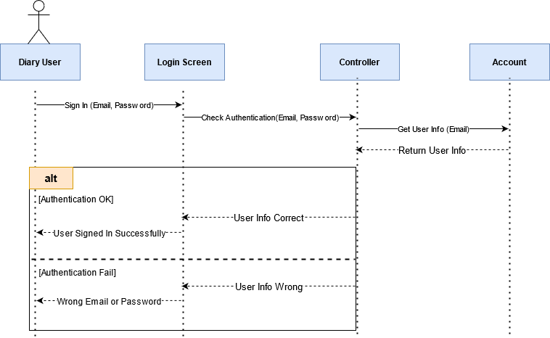

Figure 3.2.3 Login Sequence Diagram

### **3.2.3 Sequence Diagram (CONT)**

### B- Meal Notification Alarm: Users can select the meal time such as (Breakfast, Lunch, or Dinner) and at meal time, the application will send a notification alarm to the user with the meal type.

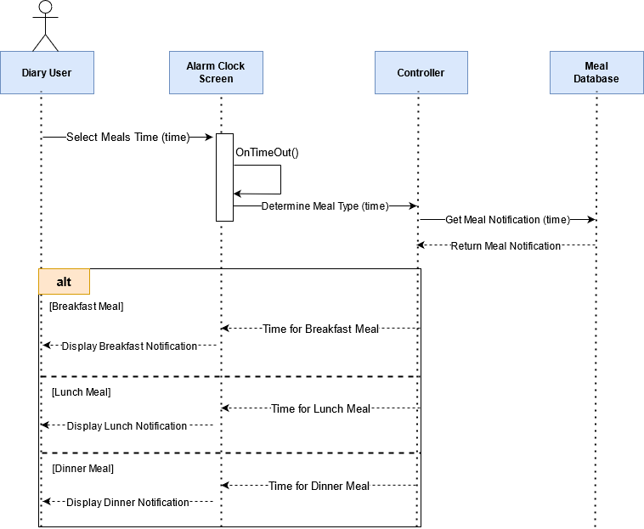

Figure 3.2.3 Meal Alarm Sequence Diagram

### **3.2.3 Sequence Diagram (CONT)**

### C- Food Tracker: Users can track the meal food using a tracker camera by capturing the meal image and the model predicts meal nutrition such as (Calories, Fats, Proteins, Carbs, etc…).

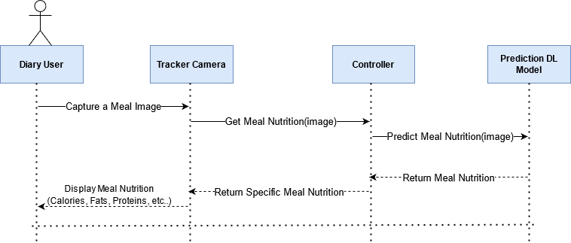

Figure 3.2.3 Food Tracker Sequence Diagram

### **3.2.3 Sequence Diagram (CONT)**

### D- Food Recommendation: Users can ask the application to recommend suitable meals based on his information such as (Height, Weight, Gender, User Goal, etc…).

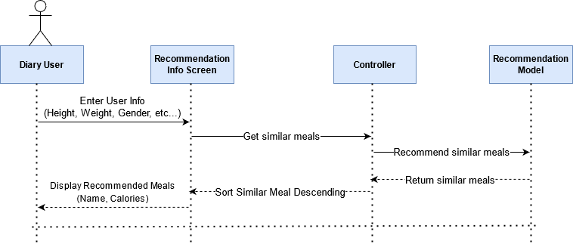

Figure 3.2.3 Recommendation Sequence Diagram

### **3.2.4 Database Diagram**

Figure 3.2.4 Database Diagram

\_\_\_\_\_\_\_\_\_\_\_\_\_\_\_\_\_\_\_\_\_\_\_\_\_\_\_\_\_\_\_\_\_\_\_\_\_\_\_\_

*Chapter 4*

*Implementation and*

*Testing*

\_\_\_\_\_\_\_\_\_\_\_\_\_\_\_\_\_\_\_\_\_\_\_\_\_\_\_\_\_\_\_\_\_\_\_\_\_\_\_\_

* 1. **A detailed description of all the functions in the system**
     + Register :

User has the ability to make a new account with needed data like user name, email, password, age, gender, height, weight, desired weight, and future goals from Lose Weight, Gain Weight, Fitness Tracker, and Patient Treatment.

* + - Login:

After registration user can log in with email and password and will be kept logged in to the system.

* + - View profile:

Users can view their personal data like name, weight, height, age, and desired weight at any time.

* + - Edit profile:

Users can edit their account passwords and edit their personal data like age, weight, height, etc.

* + - Capture images:

Users can capture their dish images to add their meals and view their nutrition details.

* + - Make notes:

Users can write their own notes.

* + - Dishes album:

The user can view all Dish images that he captures before.

* + - Get Neutrinos:

Get calories, fat, protein, and carbs from the dish image.

**4.1 A detailed description of all the functions in the system (CONT)**

* + - Generate reports:

Generates a weekly report that has the total Nutrition per gram during this week and get weekly information like if the user is close to his desired weight.

* + - View Calendar:

Users can access meals and activities on a specific day.

* Meals alarm:

Alarm the user if he exceeds the mealtime or crosses his plan.

* 1. **A detailed description of all the techniques and algorithms implemented**
* Regression model:

After the user captures the dish images, the model predicts the calories, fats, proteins, and carbs of the dish image.

* Classification model:

Get the meal name from the dish image that the user captured.

**4.3 Description of the technologies/platforms used in the implementation**

* Android Studio
* Pycharm
* Azure Cloud
* Kaggle
* Kotlin
* Python
* Java
* Firebase

**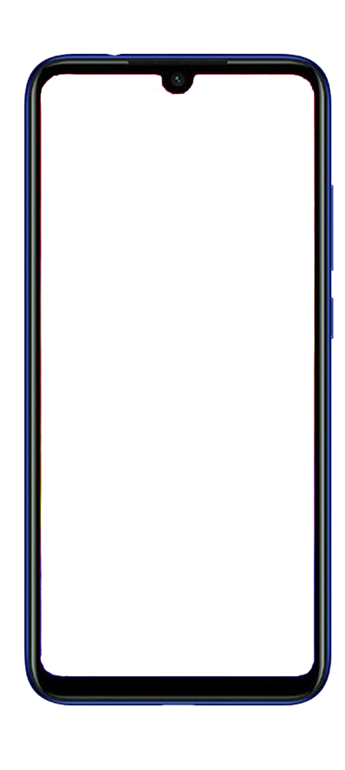4.4 UI Design and Wireframes**



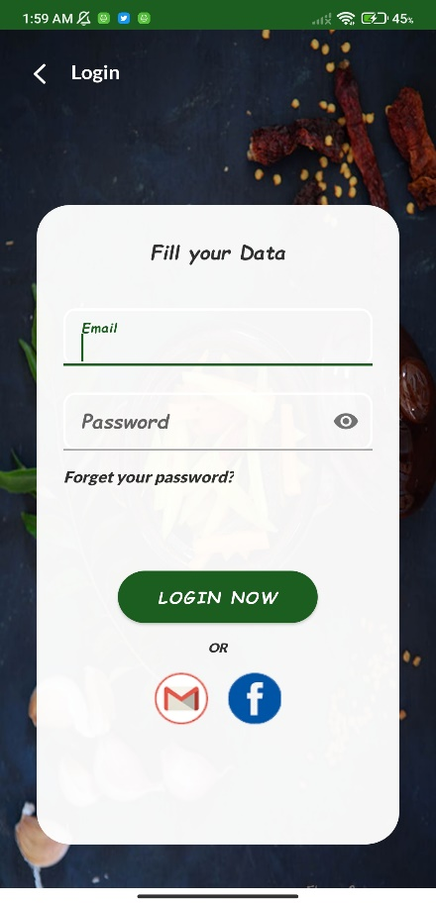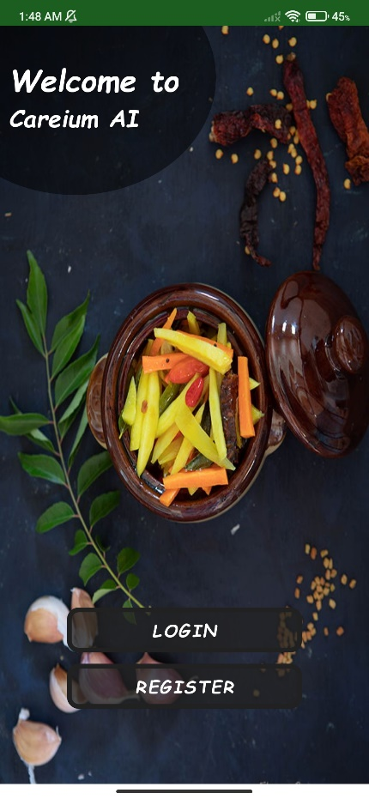



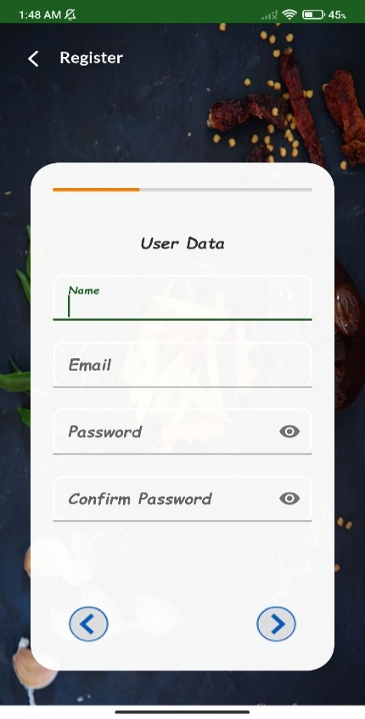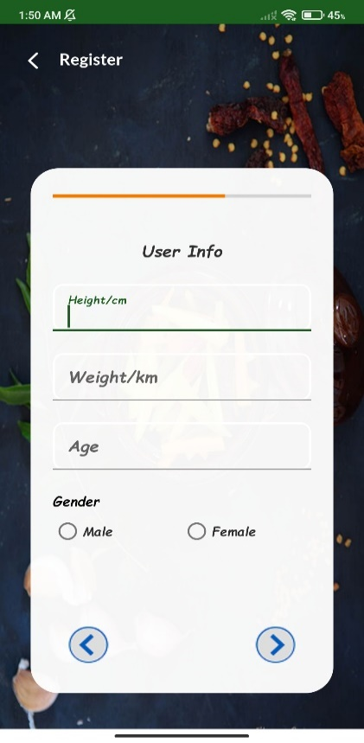

**4.4 UI Design and Wireframes (CONT)**



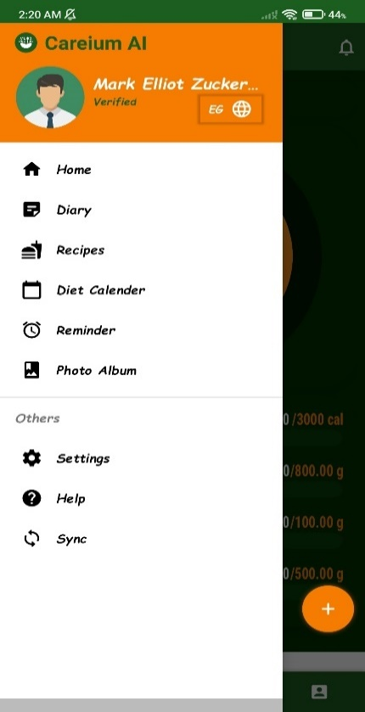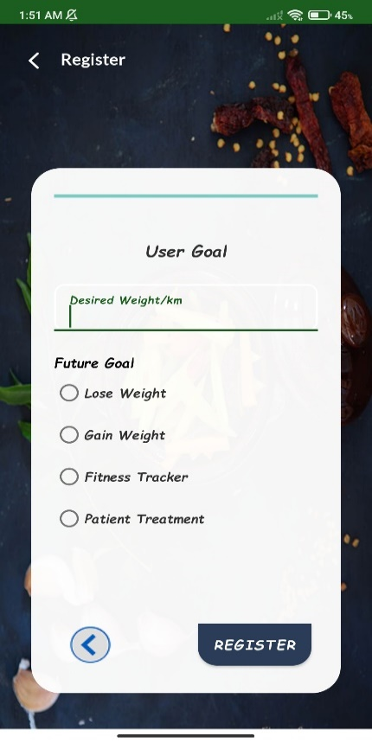



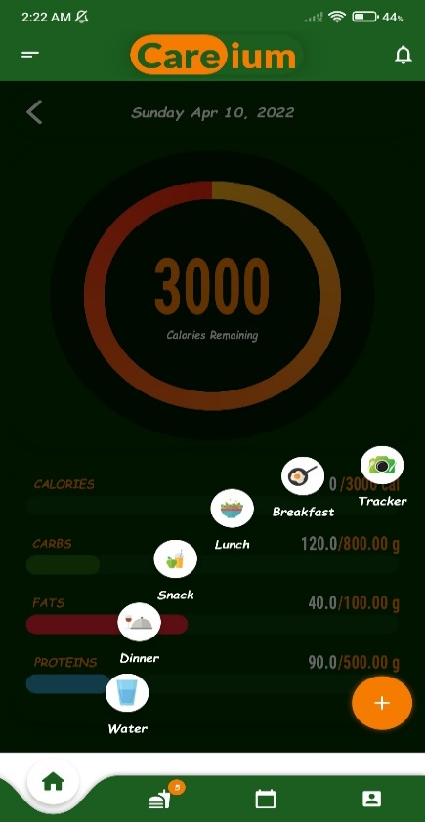

**4.5 Testing**

We have tested the application throughout three types of testing:

**1. Unit Testing** by adding unit tests to robust functions in the application.

* A snapshot of a unit test to validate the **login input**:  
  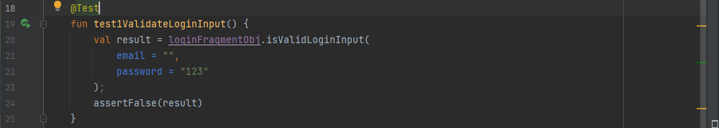
* A snapshot of another unit test to validate the **register input**:  
  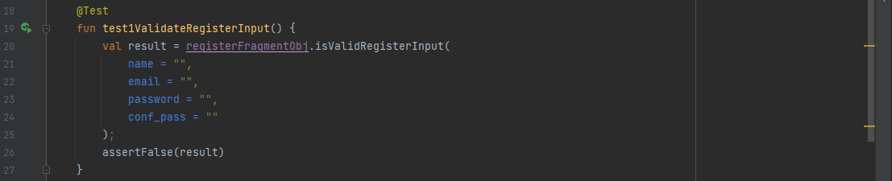

**2. UI Testing** by adding UI tests to test the visibility of the screens, text,  
 buttons, and much more.

* A snapshot shows that:  
  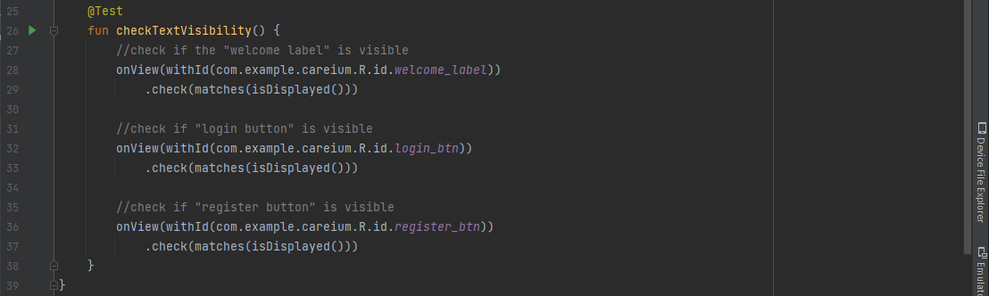

**3. Manual Testing** by making the whole team members and our colleagues test the application in its beta version and check all its functionalities.

\_\_\_\_\_\_\_\_\_\_\_\_\_\_\_\_\_\_\_\_\_\_\_\_\_\_\_\_\_\_\_\_\_\_\_\_\_\_\_\_

*Chapter 5*

*User Manual*

\_\_\_\_\_\_\_\_\_\_\_\_\_\_\_\_\_\_\_\_\_\_\_\_\_\_\_\_\_\_\_\_\_\_\_\_\_\_\_\_

**5.1 Installation Guide**

To use **Careium-AI**, you need to download the Android Application Package (APK) [**[8]**](#References_8), and then install it.   
You will **not** need to install any third-party tools.

**5.2 Getting Started**

|  |  |
| --- | --- |
| **Step 1:**    This is the first screen that appears and here you can select if you want to login or register.  A picture containing text  Description automatically generated  Figure 5.2.: Getting Started (Home) | **Step 2:**    If you click on **Login**, this screen will appear to you. So you can just enter your email and password, Or login with Facebook or Gmail.      Figure 5.2.2: Getting Started (Login) |

After installation, now it’s time to operate the application and get the most out of it. Follow the steps below:

**5.2 Getting Started (Follow UP)**

|  |
| --- |
| **Step 3:**    If you click on **Register**, you will need to enter your data into three separate screens. Screens are   * + First Screen: Name, Email, Password, and Confirm Password   + Second Screen: Height, Weight, Age, and Gender   + Third Screen: adjust your goals.           Figure 5.2.5: Getting Started (Register F3)  Figure 5.2.3: Getting Started (Register F1)  Figure 5.2.4: Getting Started (Register F2) |

**5.2 Getting Started (Follow UP)**

|  |  |
| --- | --- |
| **Step 4:**    After you log in/register successfully, you will be in the home screen. Here, click on the plus **(+)** button which is on the bottom right part of the screen.    Figure 5.2.6: Getting Started (Tracker) | **Step 5:**    After clicking on the plus button, there’re 6 icons appear. To capture a photo and get the nutrients of it, select the first icon which is **“Tracker”.** |

\_\_\_\_\_\_\_\_\_\_\_\_\_\_\_\_\_\_\_\_\_\_\_\_\_\_\_\_\_\_\_\_\_\_\_\_\_\_\_\_

*Chapter 6*

*Conclusion and*

*Future Work*

\_\_\_\_\_\_\_\_\_\_\_\_\_\_\_\_\_\_\_\_\_\_\_\_\_\_\_\_\_\_\_\_\_\_\_\_\_\_\_\_

## **6.1 Conclusion**

Having an android mobile application that helps the users to manage/track their healthy life. The user can now use the application to analyze the meal ingredients such as (tomato, onion, rice, etc…) and know the meal nutrition components such as (calories, fats, proteins, carbs, etc…) by getting the meal image using a mobile application camera.

In this project, we present **Nutrition5k** [**[7]**](#References_7), the first nutritional understanding dataset of its size, diversity, and depth of labelling. We provide evidence of the challenging nature of visual annotation in our human portion size estimation studies, demonstrating the limitations of typical data annotation approaches in this space. We validate the effectiveness of our approach to data collection and the resulting Nutrition5k dataset by training a neural network that can outperform professional nutritionists at caloric and macronutrient estimation in the generic food setting. We further introduce multiple baseline approaches of incorporating depth data to significantly improve upon our direct nutritional prediction from 2D images alone. Our hope is that the release of this project will inspire further innovation in the automatic nutritional understanding space and provide a benchmark for the evaluation of future techniques.

**6.2 Future Work**

The application can be extended with some features in the near future such as:

* Providing the application with an Arabic Food Dataset.
* Adding the walk-step counter and fats loss rate to help the user to know how often steps are walked and the daily fat loss.
* Adding Diet Programs for the people with special needs and Athlete People.
* Adding a water quantity calculator that helps the user to know his daily need for water.
* Providing robust Authentication Security and efficient Data Saving.

\_\_\_\_\_\_\_\_\_\_\_\_\_\_\_\_\_\_\_\_\_\_\_\_\_\_\_\_\_\_\_\_\_\_\_\_\_\_\_\_

*Chapter 7*

*References*

\_\_\_\_\_\_\_\_\_\_\_\_\_\_\_\_\_\_\_\_\_\_\_\_\_\_\_\_\_\_\_\_\_\_\_\_\_\_\_\_

**7.1 References**

1. Image Based Calorie Estimating using Deep Learning, author: Binayak Pokhran, July 09, 2019: (Last Accessed on 11-2021)   
   <https://www.lftechnology.com/blog/ai/image-calorie-estimation-deep-learning/>.
2. Food Detection and Recognition using Convolution Neural Network,

Author: Hokuto Kagaya, Nov 22, 2014: (Last Accessed on 11-2021)   
<https://dl.acm.org/doi/abs/10.1145/2647868.2654970>

1. Food Recognition using InNet Model, author: Chakkrit Termritthikun,

Aug 01, 2017: (Last Accessed on 11-2021)   
<https://paperswithcode.com/paper/nu-innet-thai-food-image-recognition-using>

1. Food Calories Estimation Using Machine Learning, author: Vishakha A. Metre

Apr 09, 2021: (Last Accessed on 12-2021)   
<https://ieeexplore.ieee.org/document/9397023>

1. HealthifyMe -> related existing application: (Last Accessed on 03-2022)

<https://play.google.com/store/apps/details?id=com.healthifyme.basic&hl=en&gl=US>

1. Myfitnesspal -> related existing application: (Last Accessed on 05-2022)  
   <https://www.myfitnesspal.com/>
2. Nutrition5k dataset: (Last Accessed on 05-2022)  
   <https://github.com/google-research-datasets/Nutrition5k>
3. Careium APK (app release): (Last Accessed on 07-2022)  
   <https://drive.google.com/drive/folders/1nRSwTNkt4A0v-eDkRlX9mrywlo5ADhrR?usp=sharing>
4. Neural Networks and Deep Learning Course: (Last Accessed on 02-2022)  
   <https://www.youtube.com/watch?v=UKk3K0g7cP8&list=PL6-3IRz2XF5UiBoBDgeu5T3TyOIrgQ3r9>
5. Recommender Systems in Machine Learning: (Last Accessed on 04-2022)  
   <https://www.youtube.com/watch?v=giIXNoiqO_U>
6. Keras with TensorFlow Course: (Last Accessed on 01-2022)  
   <https://www.youtube.com/watch?v=qFJeN9V1ZsI>
7. Microsoft Azure Cloud: (Last Accessed on 05-2022)  
   <https://www.youtube.com/watch?v=3Arj5zlUPG4>